bibliographic Information ツ

Author(s):
Nicolas Ragot, Redouane Khemmar, Adithya Pokala, Romain Rossi, Jean-Yves Ertaud.
Title of article or book (if a chapter in a book, put the chapter # and title here, and put the title of the book in “Title of publication”):
2019 Eighth International Conference on Emerging Security Technologies (EST
Title of publication, including Vol., Num., date (if article in magazine, newspaper, or journal):
Benchmark of Visual SLAM Algorithms: ORB-SLAM2 vs RTAB-Map
Page numbers (if article in magazine, newspaper, or journal):
1-7
Publisher:
HAL Science
Date published:
Jul 2019
URL (if applicable):
https://hal.science/hal-02343341 I dont even know
MLA citation:
Nicolas Ragot, Redouane Khemmar, Adithya Pokala, Romain Rossi, Jean-Yves Ertaud. Benchmark of Visual SLAM Algorithms: ORB-SLAM2 vs RTAB-Map. 2019 Eighth International Conference on Emerging Security Technologies (EST), Jul 2019, Colchester, United Kingdom. ⟨10.1109/EST.2019.8806213⟩. ⟨hal-02343341⟩

Direct quotes: Include Page #s (For each quote, provide some context and/or analysis; you may also want to re-state the information in your own words. Quotes from your sources, and your understanding of them, will make up the bulk of your literature review)
- 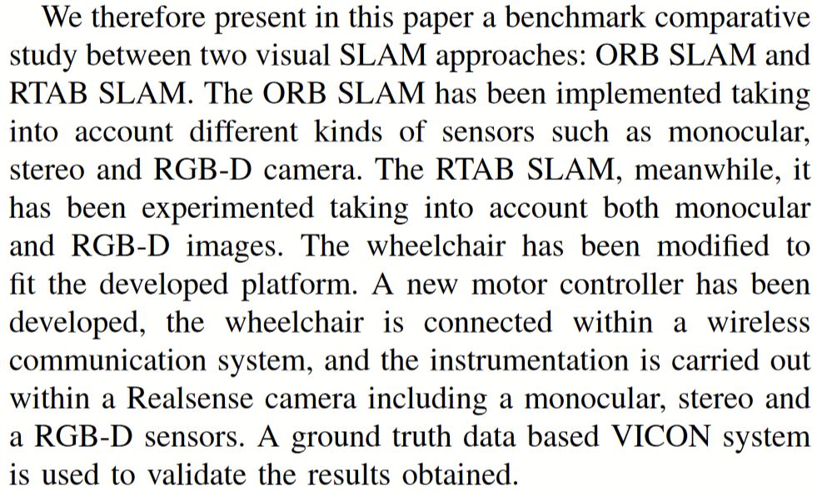p3
- 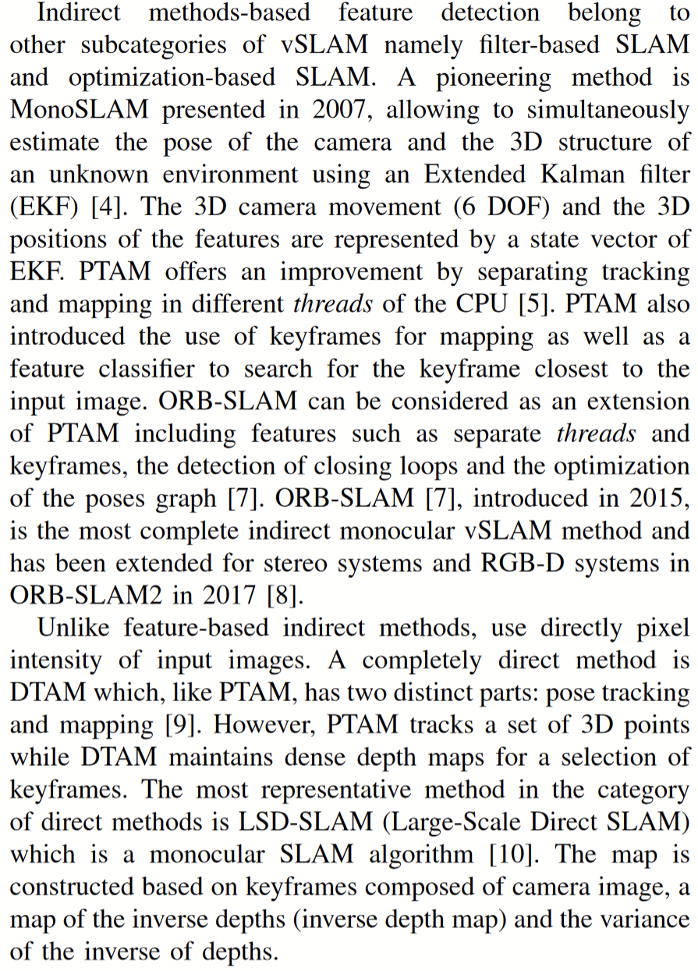p3
- 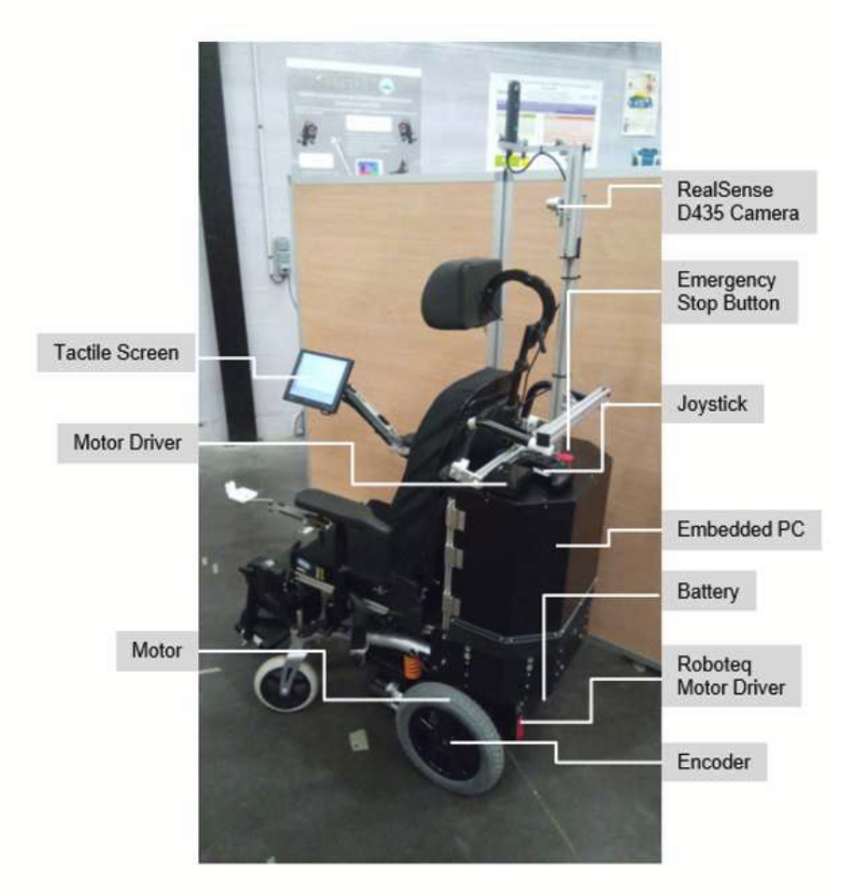p4
- 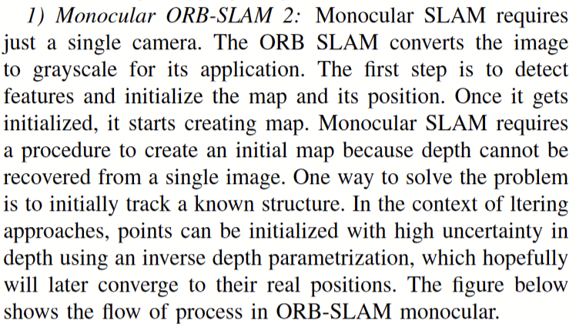p4
- 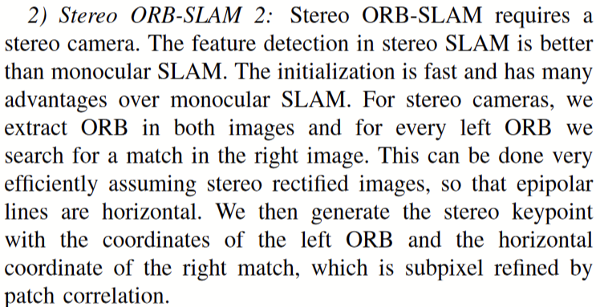p4
- 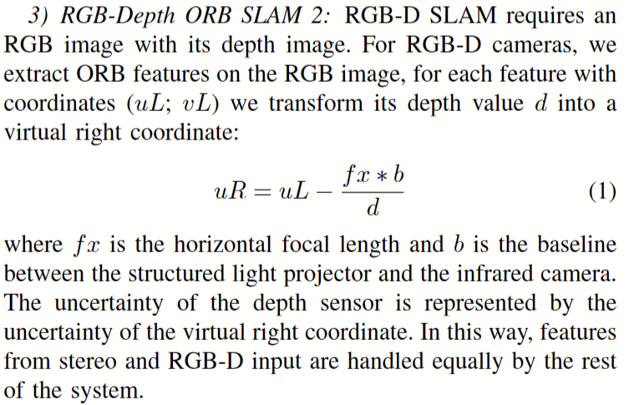p4
- 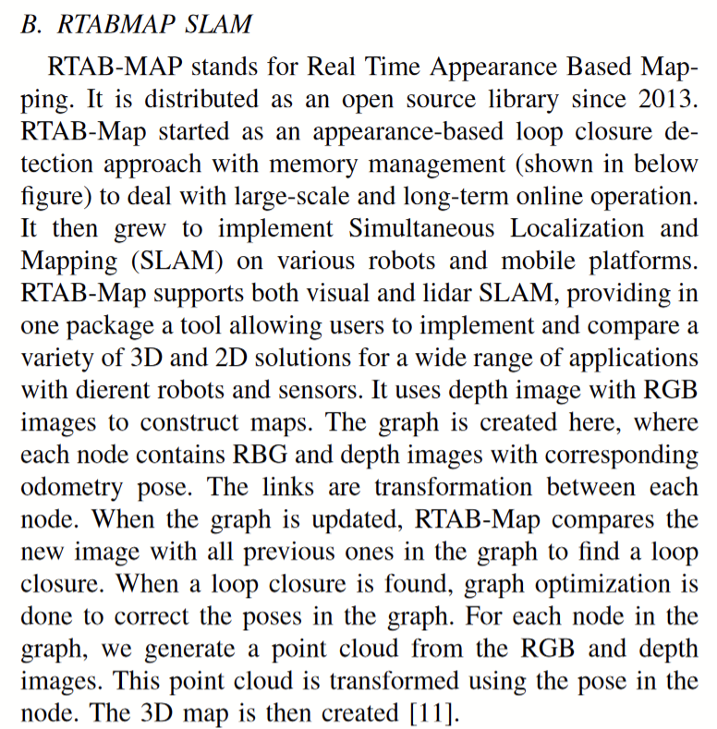p5
- 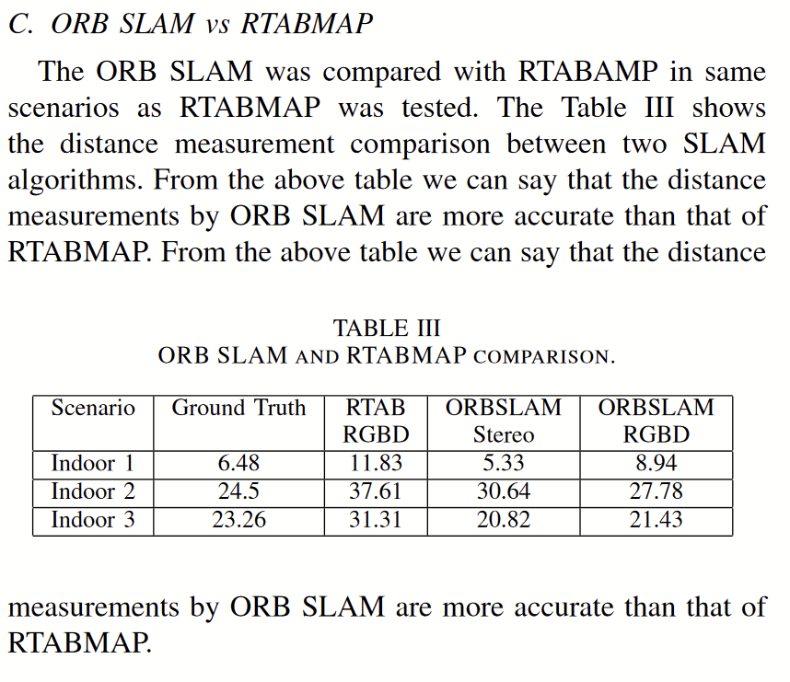p6

Paraphrased Notes: Include Page #s (This is a space for you to track the flow of information, and the ways in which the article engages with other works.)

Summary of Source (2-4 sentences)
This study compares ORB-SLAM2 and RTABMAP. It finds that overall orbslam did better, but i don’t think this study is that important, as it is 2 very different sensor fusions.

Does this help me answer my question? Why or why not?
Yes, slam

Lingering Questions
Bro why are they doing slam on a WHEELCHAIR

Connections to other sources
Whadaya know, its slam

